Lab 11: Class and Function Templates
Covering Lectures: 32 - 33
Objective:
- This Lab aims to give students a deep understanding of Functions and Class templates.
Learning Outcomes:
- After completing this lab, students can practice generic programming in their programs.

Problem Statement:
You are required to develop a generic inventory management system in C++. Design a system that can store and manage different types of products such as Books and Electronics using generic code.

Requirements:

1. Product Classes (Non-template)
Define two product classes with different attributes:
- Book with data members: title, author, price.
- Electronic with data members: name, brand, price.
Each class must implement:
- A default constructor
- A parametrized constructor
- A method to display details
- A getter for price

2. Class Template Inventory<T>
Create a class template to manage an array of any product type:
- addItem(T)
- displayItems()
- getItems()
- getCount()

3. Function Template findMax<T>
Write a function template that takes an array of items and returns the one with the maximum price using getPrice() method.

4. In main():
- Create inventories for Book and Electronic.
- Add multiple products using addItem().
- Display items.
- Find and display the most expensive item in each inventory.

Sample Output:
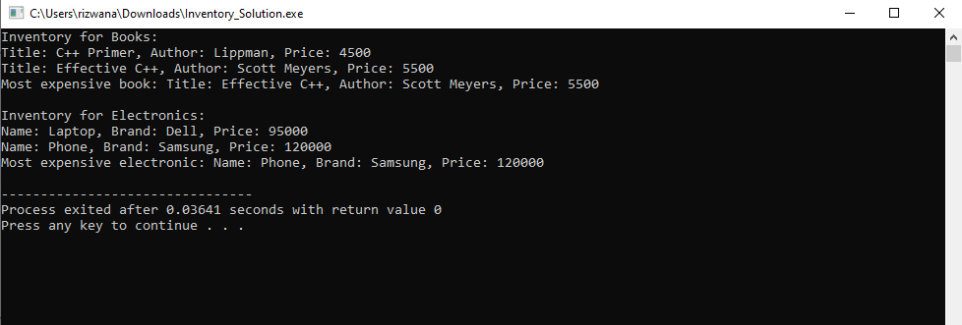

Practice Questions:
- Write a C++ code for swapping the data of two variables. The variables can be of any type (int, float, char etc.) using the function templates.
- Write a C++ Program to find the Sum of an Array using a class template. The array elements can be int, float, and double types. Character type data is not allowed.
- Write a C++ Program to find the Square of a number using a single template class. The number can be an integer, float, or double data type.

